This problem will be worth 11 points. There is the one student tester and 10 additional tests for a total of 11 tests.

This problem will ask you to implement the following functions. One function is defined recursively. Other times I will give you functions from the java.lang.Math with a brief description, and some times you just need to implement the function. In all the following functions you do NOT need worry about domain issues. That is, you may assume that all test data will not cause any exceptions to be thrown. In total, there are nine different functions in this problem. Each successfully implemented function will earn you a point. Complete all 9 and you will earn the tenth point from this problem. Except for the first method, all methods will return a double. You method must return value within 0.05 of the correct answer to be considered correct.

- Implement the following recursive function. A recursive solution will earn you this point, but for negative values of n <= -179999 at stack overflow may occur. To earn the eleventh point in this problem, you will need to implement this function in a non-recursive solution.
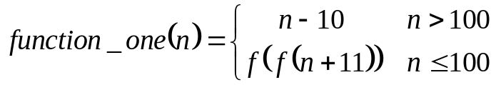
using the following function heading:
public static int function_one(int n)

Test data: function_one(10) returns 91

Note: The correct call to a recursive static method is of the form:
FunctionsGoneWild.function_one(n)

- Implement the following rational function.
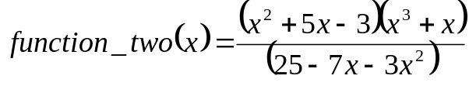
using the following function heading:
public static double function_two(double x)

Test data: function_two(-5) returns -26

- Implement the following function.
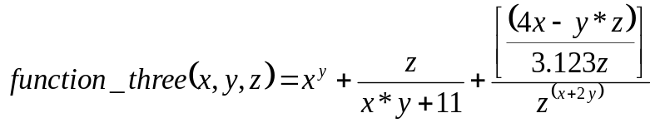
using the following function heading:
public static double function_three(double x, double y, double z)

Test data: function_three(1, 1, 1) returns 2.0439481

- Implement the following function
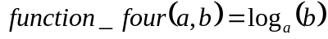 using the fact 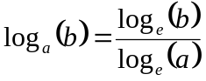, 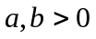
Useful (static) function from java.lang.Math. Recall static methods are invoked using the Class name, for example the following method is invoked in the following manner:
Math.log(a).
log(double a) | Returns the natural logarithm (base e). This method returns a double.
Use following function heading:
public static double function_four(double a, double b)

Test data: function_four(2, 1)) returns 0

- Implement the following function
,
Useful (static) function from java.lang.Math. Recall static methods are invoked using the Class name, for example the following methods are invoked in the following manner:
Math.log(a) and Math.log10(a)
log(double a) | Returns the natural logarithm (base e). Returns a double.
log10(double a) | Returns the common logarithm (base 10). Returns a double.
Use following function heading:
public static double function_five(double a, double b)

Test data: function_five(54321, 123.7)) returns 1941.227076

- Implement the following function
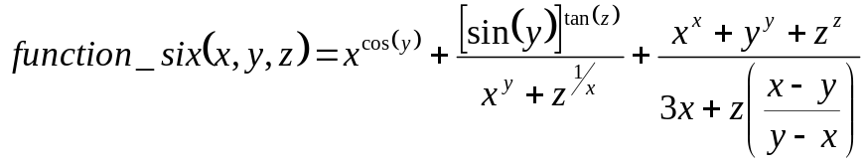
Useful functions from java.lang.Math. Recall static methods are invoked using the Class name, for example the following methods are invoked in the following manner:
Math.cos(anAngle) or Math.sin(anAngle) or Math.tan(anAngle)
cos(double a) | Returns the trigonometric cosine of an angle. This method returns a double.
sin(double a) | Returns the trigonometric sine of an angle. This method returns a double.
tan(double a) | Returns the trigonometric tangent of an angle. This method returns a double.
Use following function heading:
public static double function_six(double x, double y, double z)

Test data: - function_six(2.3, 1, 3.0)) returns 10.75125008

- Implement the following function
Use following function heading:
public static double function_seven(double x, double y, double z)

- Implement the following function
Use following function heading:
public static double function_eight(double a, double b)

- Implement the following function
Use following function heading:
public static double function_nine(double a, double b,
double x, double y, double z)

Each of the above functions is tested individually. Each function that is correctly implemented will earn one point. The tenth and final point is a bonus point for correctly implementing all nine functions!

